Project Proposal

The main idea for my project is to build an infinitely generating world that you can walk around and move through and explore. There will be a day night cycle with a dome/sphere skybox that moves with the character. The character will collide with the ground and will have full motion using keyboard and mouse controls.

Nikkolas Diehl 16945724

Core requirements:

* Animated spotlight: You will be able to click *L* to turn on your flash light which will be important at night and is optional in the day
* Texture mapping: I will be texture mapping the ground, trees that generate and any animals I plan to have. I plan on having some seagulls in the morning near water, and owls at night. And I will texture map the sky box.
* Grid Ground: I will be using some form of fractal terrain generation algorithm to generate infinite amount of terrain
* Object to track: I will be creating a simple character with a sphere hit box. I will then have the option between first person and 3rd person tracking cams that will follow the character.
* Fly by: Character will be keyboard and mouse controlled but will be a few simple polygons on a sphere. I might make it similar to Eve in wall-e where it’s a robot on a rolling ball. This will be an entirely hierarchical model with a camera, moving light and moving sky dome also moving with the character
* Fog use: Fog will be used to hide distant objects. I plan to have an array list for terrain that will hold any generated terrain. If you generate anything, it will always save that location so you can go back to it. Any new terrain is saved into this array list which I might also have saved into a file so you can load up previously saved files. Terrain at a certain distance around you will not be generated or drawn. Fog will also massively increase at night time to add to the illusion

One thing I plan on or have an idea on is tree generation:

* I will have a forest controller. The forest controller will have a chance to spawn a new forest with a random size and density every time you generate a new ‘chunk’ of land. Each forest will have an array list of random locations inside the size range. Each location, when generated will check if the location already exists. If it does, it will re-generate. Once it finishes generating an amount equal to the density, it will then spawn trees at those locations. That way a forest; in theory, will never have colliding trees.

All mesh objects that I use will come from here: <https://free3d.com/3d-models/>

* Forests, when generated, will pick a random tree type out of these tree types:
  + <https://free3d.com/3d-model/low-poly-tree-73217.html>
  + <https://free3d.com/3d-model/low-poly-tree-449895.html>
  + <https://free3d.com/3d-model/cartoon-low-poly-trees-895299.html>
  + <https://free3d.com/3d-model/low-poly-tree-18385.html>
  + <https://free3d.com/3d-model/low-poly-tree-24775.html>
  + <https://free3d.com/3d-model/low-poly-pine-tree-223731.html>
  + <https://free3d.com/3d-model/a-palm-tree-with-coconuts-588359.html>
  + <https://free3d.com/3d-model/low-poly-tree-v1-146606.html>
* Birds, when generated, will pick either a morning bird or a night bird:
  + <https://free3d.com/3d-model/mallard-55535.html>
  + <https://free3d.com/3d-model/owl-v1--354894.html>
  + <https://free3d.com/3d-model/owl-27319.html>
  + <https://free3d.com/3d-model/eagle-2-59246.html>
  + <https://free3d.com/3d-model/gull-17126.html>
  + <https://free3d.com/3d-model/goose-78428.html>

Textures will come mostly from the models themselves, and for grass the texture will probably something similar to this: <https://www.brusheezy.com/textures/20185-seamless-green-grass-textures> Or what I might go for is a low poly art style and just have slightly different shades of green for the terrain.

The skybox will actually be two sky boxes. One overlaid the other and slightly smaller. This is so I can have what looks like a very 3D cloud layer with sky behind it.

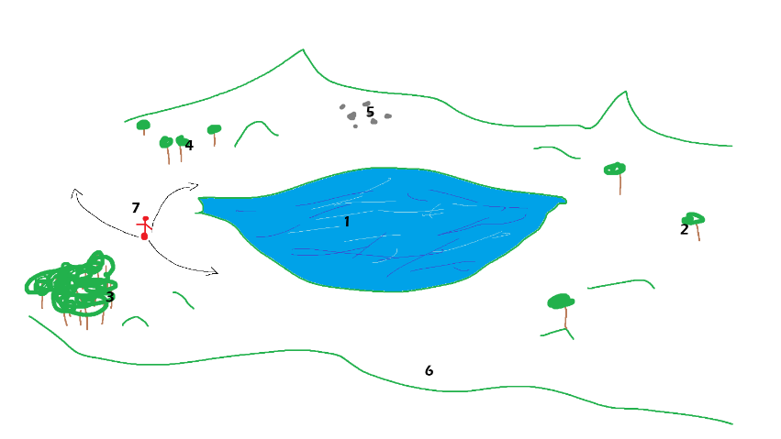Water will be a large flat terrain generating underneath the terrain at a certain height with a similar texture

Ideas:

1. Water will be generated as a flat terrain surface at a certain height. Probably ~ 0 ~. Any land terrain that goes bellow y=0 will have water showing through. I might also choose to have water as cubes being generated in the same way that terrain is, so that the water has volume when you enter it.
2. This is an example of a very big, but very low-density forest. These will have a chance generate at random locations with a random size and density.
3. This is an example of a high density, small forest.
4. This is an example of a low density, small forest
5. I also plan to have flocks of birds that fly around at random locations. These birds will spawn in similar ways to forests but will be removed from array lists when they are too far away making them randomly show up
6. Land will be a fractal terrain generation algorithm that random generates height and depth and hills and so on.
7. The player will be able to be controlled using *wasd* for movement, *mouse* for looking, *space* for jump and *L* for flashlight with will be an animated moving spot light.

There will be a dome skybox that moves with the player. The texture will rotate slowly creating a day night cycle. There will be a texture wrapped on the inside of the sphere and 2-point lights will move with this rotation. One very bright and yellow one for the sun, and one blue, dark one for the moon.

Textures to use:

Grass:

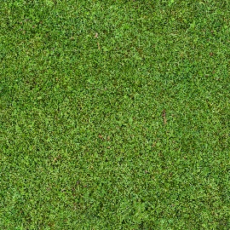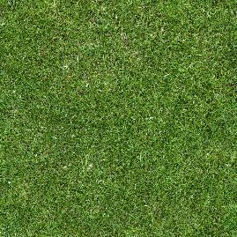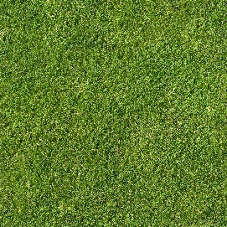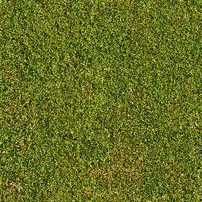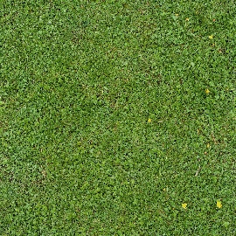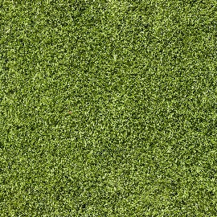

Water:

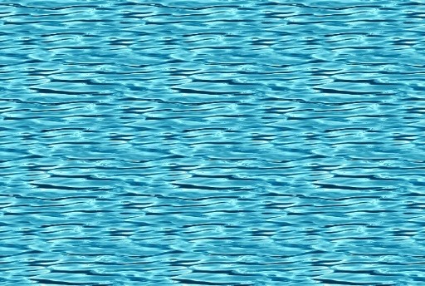

Sky:

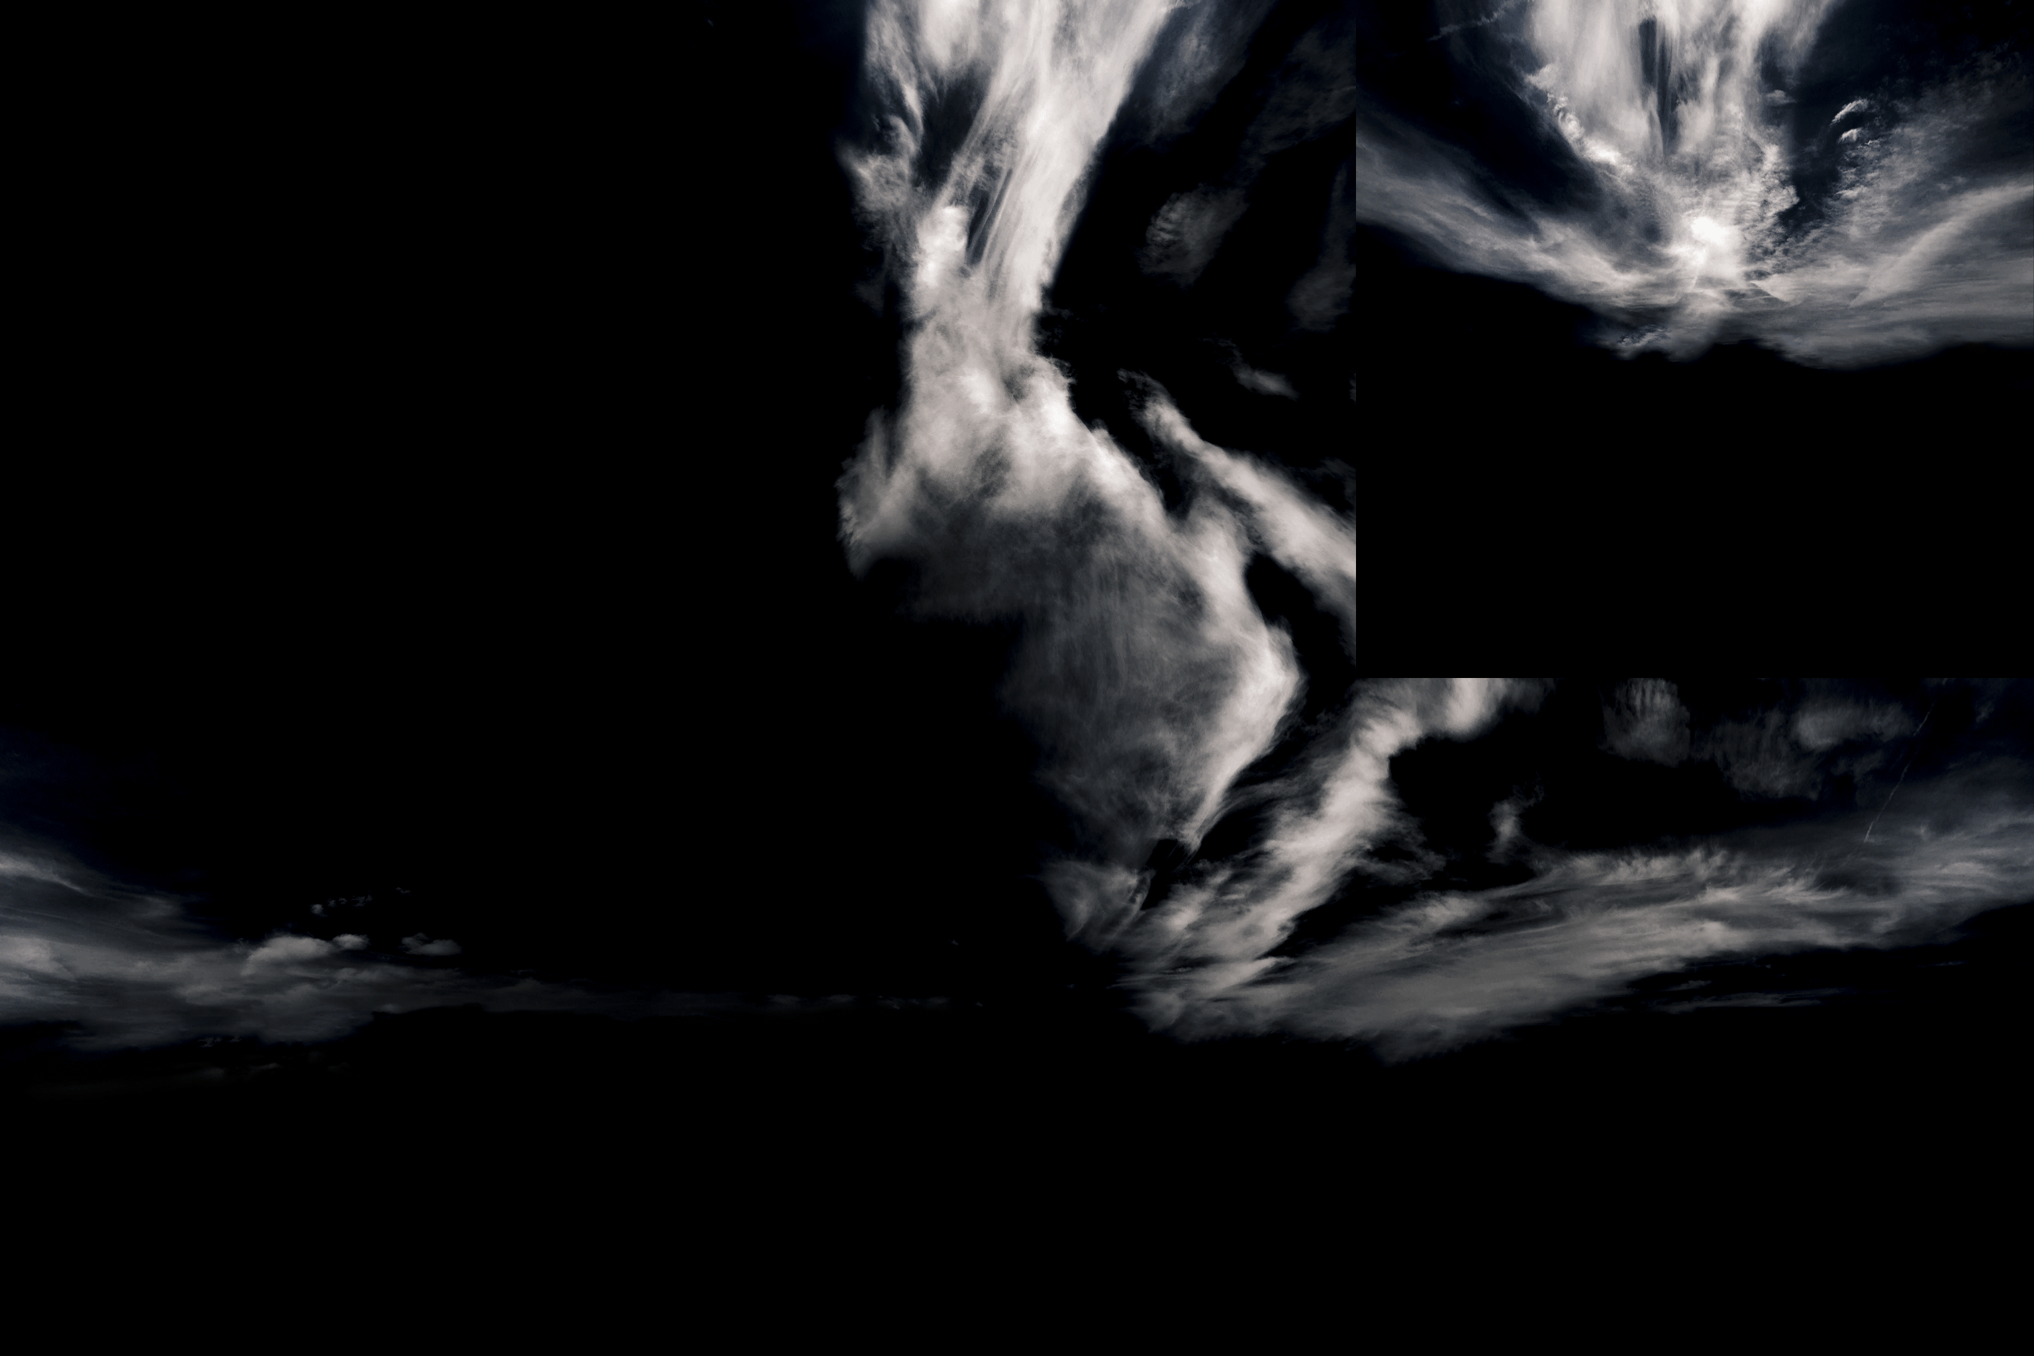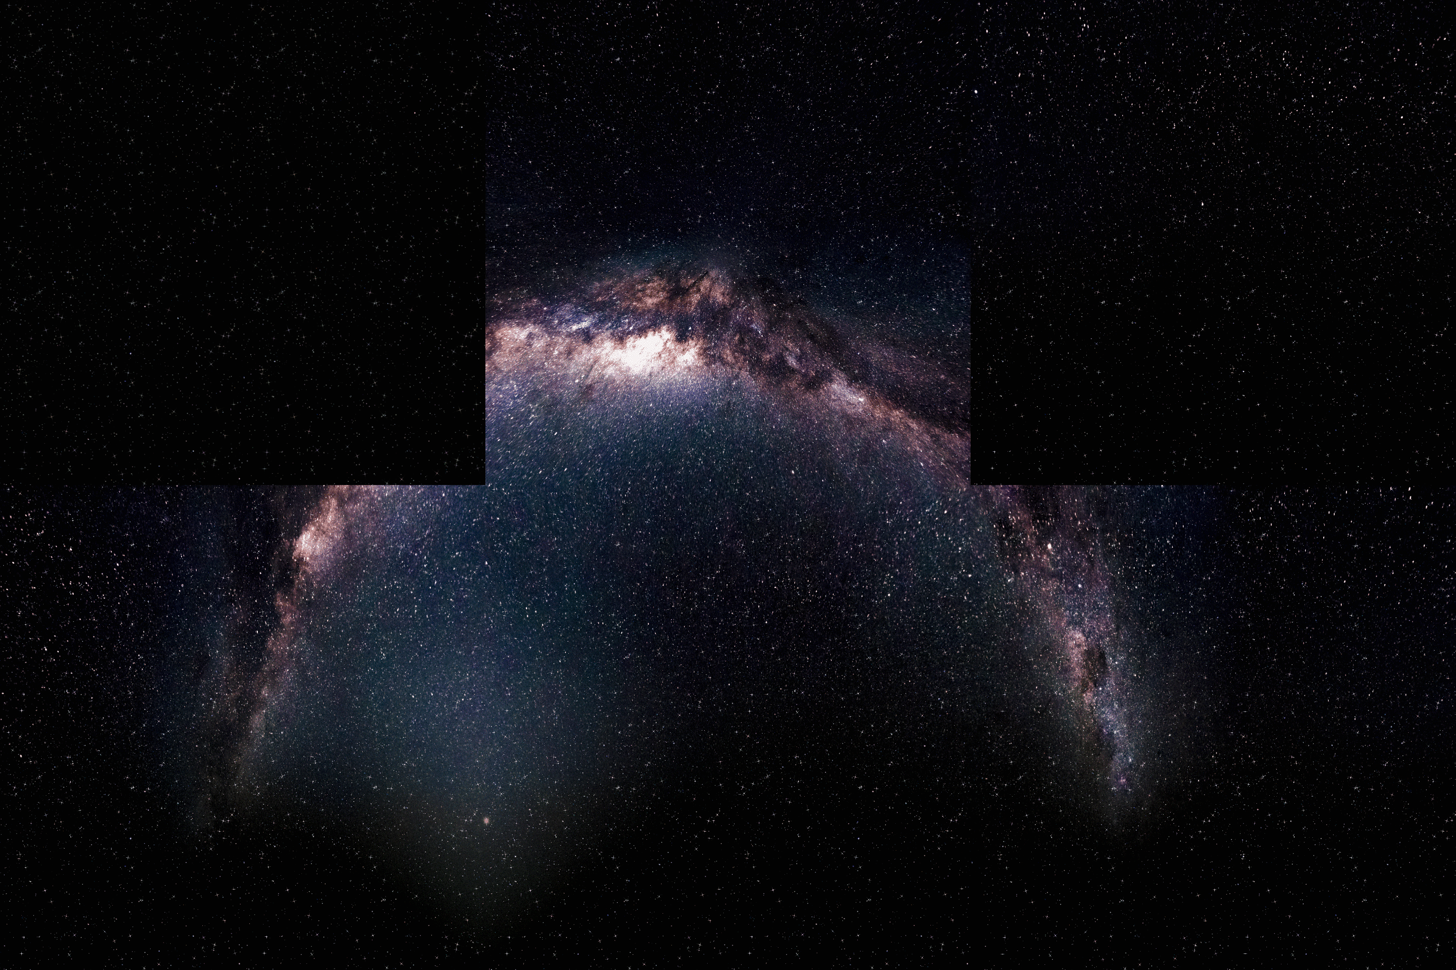

Objects to use:

Trees:

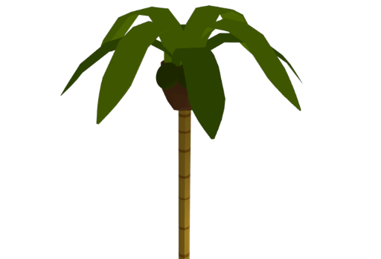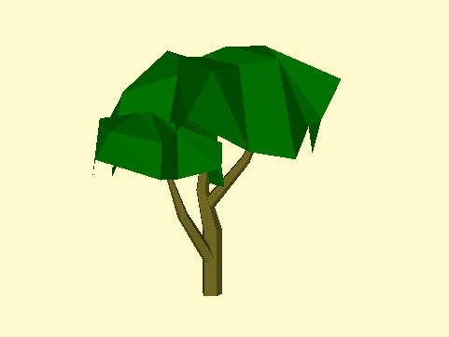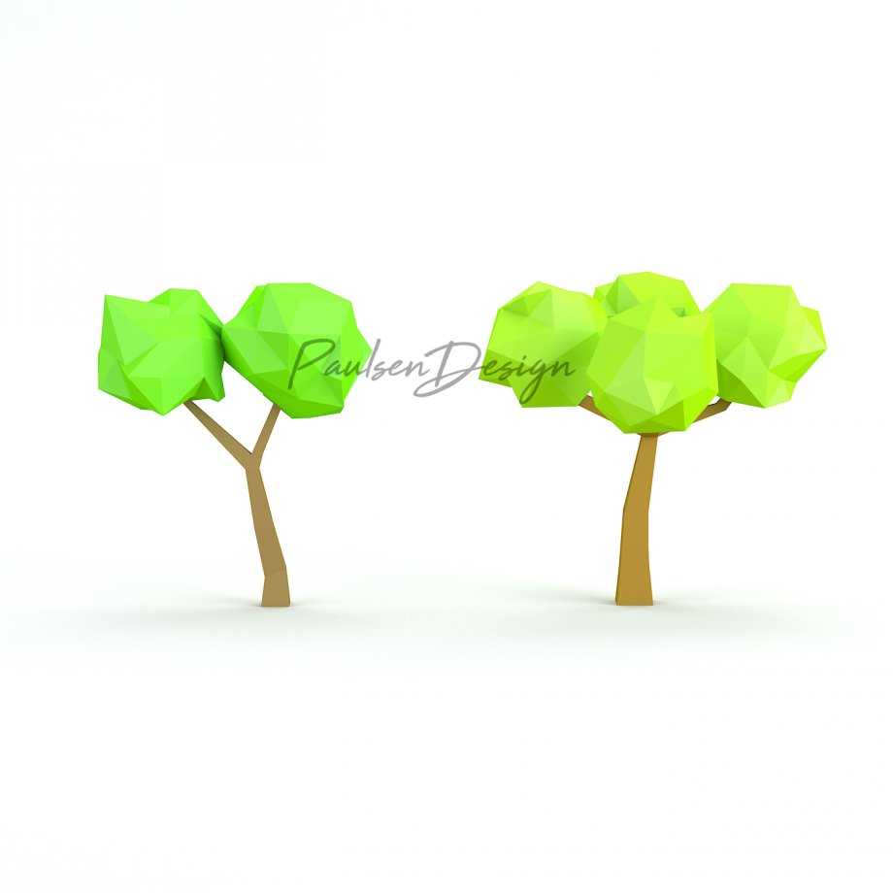

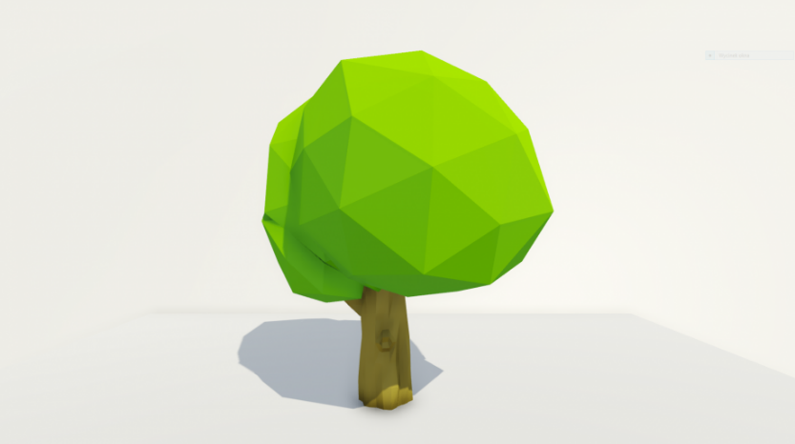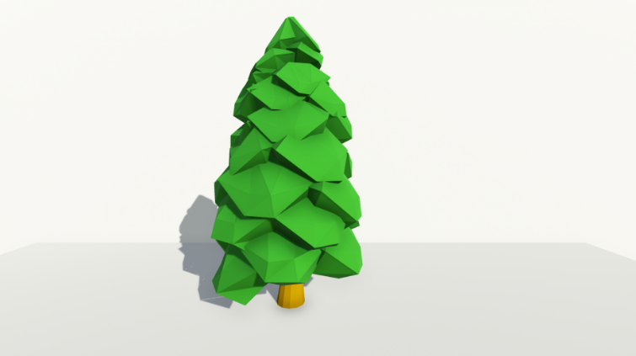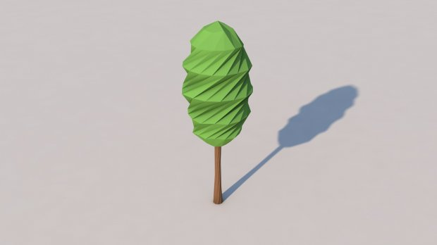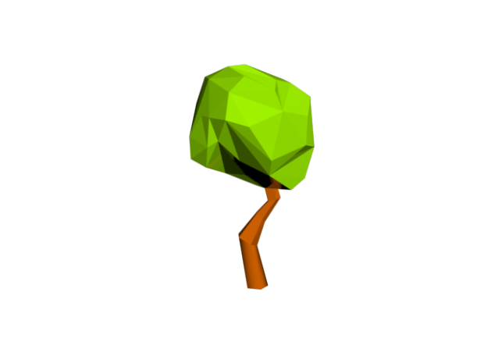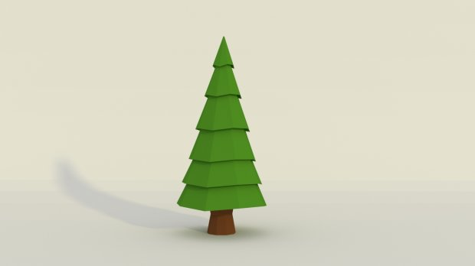

Birds:

